**Watch the following videos and write a short paragraph about 2 of them. Note: ELIZA is not a video, it is a simulation.**

**Watson**

Watson is a question-answering computer system capable of answering questions posed in natural language, developed in IBM's DeepQA project by a research team led by principal investigator David Ferrucci. Watson was named after IBM's founder and first CEO, industrialist Thomas J. Watson.

The computer system was initially developed to answer questions on the quiz show Jeopardy! and, in 2011, the Watson computer system competed on Jeopardy! against champions Brad Rutter and Ken Jennings, winning the first place prize of $1 million.

Watson uses IBM's DeepQA software and the Apache UIMA (Unstructured Information Management Architecture) framework implementation. The system was written in various languages, including Java, C++, and Prolog, and runs on the SUSE Linux Enterprise Server 11 operating system using the Apache Hadoop framework to provide distributed computing.

The system is workload-optimized, integrating massively parallel POWER7 processors and built on IBM's DeepQA technology, which it uses to generate hypotheses, gather massive evidence, and analyze data.  Watson employs a cluster of ninety IBM Power 750 servers, each of which uses a 3.5 GHz POWER7 eight-core processor, with four threads per core. In total, the system has 2,880 POWER7 processor threads and 16 terabytes of RAM.

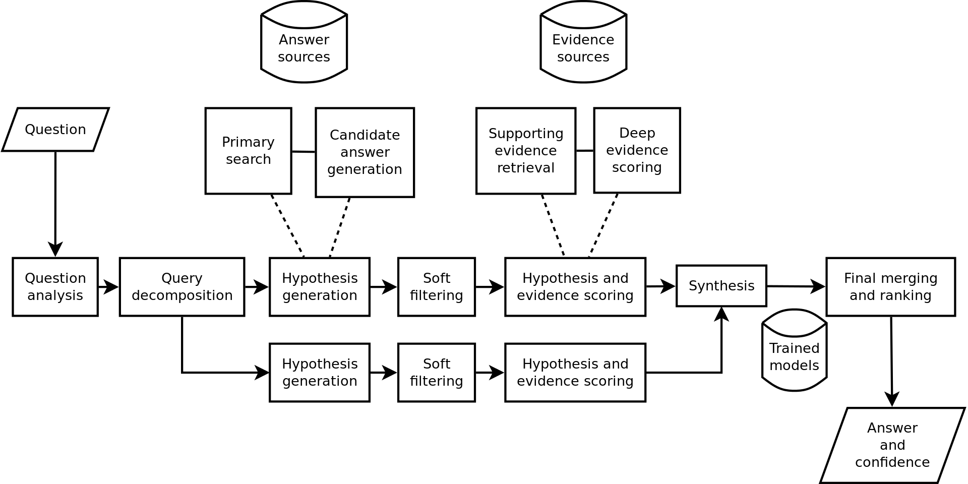

Checkout this video.

<https://www.youtube.com/watch?v=4svcCJJ6ciw>

**Eliza**

ELIZA is an early natural language processing computer program created from 1964 to 1966 at the MIT Artificial Intelligence Laboratory by Joseph Weizenbaum. Created to demonstrate the superficiality of communication between humans and machines, Eliza simulated conversation by using a "pattern matching" and substitution methodology that gave users an illusion of understanding on the part of the program, but had no built in framework for contextualizing events.  Directives on how to interact were provided by "scripts", written originally in MAD-Slip (an ancient programming language, which allowed ELIZA to process user inputs and engage in discourse following the rules and directions of the script. The most famous script, DOCTOR, simulated a Rogerian psychotherapist (in particular, Carl Rogers, who was well-known for simply parroting back at patients what they'd just said), and used rules, dictated in the script, to respond with non-directional questions to user inputs. As such, ELIZA was one of the first chatterbots and one of the first programs capable of attempting the Turing test.

ELIZA's creator, Weizenbaum regarded the program as a method to show the superficiality of communication between man and machine, but was surprised by the number of individuals who attributed human-like feelings to the computer program, including Weizenbaum’s secretary. Many academics believed that the program would be able to positively influence the lives of many people, particularly those suffering from psychological issues, and that it could aid doctors working on such patients' treatment.  While ELIZA was capable of engaging in discourse, ELIZA could not converse with true understanding.  However, many early users were convinced of ELIZA’s intelligence and understanding, despite Weizenbaum’s insistence to the contrary.

Try out ELIZA at this web site.

<http://psych.fullerton.edu/mbirnbaum/psych101/Eliza.htm>

**Open Source Software**

Open-source software (OSS) is a type of computer software in which source code is released under a license in which the copyright holder grants users the rights to study, change, and distribute the software to anyone and for any purpose.  Open-source software may be developed in a collaborative public manner. Open-source software is a prominent example of open collaboration.

Check out this video

<https://www.youtube.com/watch?v=SpeDK1TPbew>

**Mozilla Coderush**

Netscape Navigator was a proprietary web browser, and the original browser of the Netscape line, from versions 1 to 4.08, and 9.x. It was the flagship product of the Netscape Communications Corp and was the dominant web browser in terms of usage share in the 1990s, but by 2002 its use had almost disappeared.  This was primarily due to the increased use of Microsoft's Internet Explorer web browser software, and partly because the Netscape Corporation (later purchased by AOL) did not sustain Netscape Navigator's technical innovation in the late 1990s.

The business demise of Netscape was a central premise of Microsoft's antitrust trial, wherein the Court ruled that Microsoft's bundling of Internet Explorer with the Windows operating system was a monopolistic and illegal business practice. The decision came too late for Netscape, however, as Internet Explorer had by then become the dominant web browser in Windows.

The Netscape Navigator web browser was succeeded by the Netscape Communicator suite in 1997. Netscape Communicator's 4.x source code was the base for the Netscape-developed Mozilla Application Suite, which was later renamed SeaMonkey.  Netscape's Mozilla Suite also served as the base for a browser-only spinoff called Mozilla Firefox.

The Netscape Navigator name returned in 2007 when AOL announced version 9 of the Netscape series of browsers, Netscape Navigator 9. On December 28, 2007, AOL canceled its development but continued supporting the web browser with security updates until March 1, 2008. AOL allows downloading of archived versions of the Netscape Navigator web browser family. AOL maintains the Netscape website as an Internet portal.

Checkout this video on the transition from the commercial product of Netscape Communicator to Open Source Mozilla.

<https://www.youtube.com/watch?v=4Q7FTjhvZ7Y>

**Revolution OS**

Revolution OS is a 2001 documentary film that traces the twenty-year history of GNU, Linux, open source, and the free software movement. You can watch this documentary at

<https://www.youtube.com/watch?v=4vW62KqKJ5A>